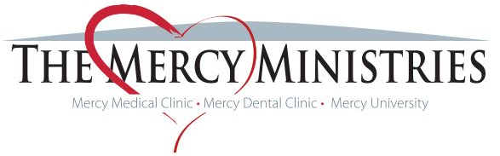
Who We Are: The Mercy Ministries (TMM) is a faith-based 501(c)3 non-profit organization made up of a collective group of services (Mercy Medical Clinic, Mercy Dental Clinic, and Mercy University) aimed at providing holistic healthcare to those in need for individuals living within a 45-mile radius of Lyons, Ga.
Who We Serve: The Mercy Ministries’ medical and dental services are available (upon application) for the uninsured, low-income (200% the FPL or below) population between the ages of 19-63 that are ineligible for Medicaid in the state of Ga. because they are not disabled or pregnant. Applicants must also have some type of chronic illness (i.e. diabetes, hypertension, heart disease, etc.) or on-going issue that needs to be managed by a primary care provider. The Mercy Ministries’ Mercy University program is available to TMM’s active medical/dental patients as well as the community at large.
Mission: To transform lives by putting God’s love into action
Vision: To eliminate the gaps to healthcare and wellness in every community
Values:
- Evangelism - We will intentionally share the Gospel with word and action in all we do.​
- Integrity - Everything we do will be above reproach for the sake of our organization and those who support it.
- Respect - In all things we will lead people to value themselves, and in return, value others.​
- Compassion - Loving God's children by seeking solutions to alleviate their suffering.​
- Accountability - We will not enable people to maintain the status quo; growth is the only option.
- Community - We believe isolation is toxic and thus encourage Biblical community throughout our programs.
- Excellence - In everything, we will be prayed up, organized, and will execute our tasks with passion!​
Mission Message: We offer a healthier way to do life for hundreds of people living in a cycle of poverty in Toombs County and surrounding areas through transformation of heart, health and community.
Services Offered:
Transformation of the heart encompasses everything we do at The Mercy Ministries to share the love of Christ with those we serve, including pastoral care, counseling and prayer. In fact, every morning we have prayer in the lobby at 8:30. All present staff, volunteers and patients gather in a circle, hold hands, and pray. We average 12 people in our prayer circle each day; it’s a beautiful sight to behold!
Transformation of health encompasses all the services provided at The Mercy Ministries to improve patients’ physical health including: Mercy Medical Clinic and Mercy Dental Clinic.
Mercy Medical Clinic
The Mercy Medical Clinic provides free primary medical care, access to medications, health education and specialty referrals to over 500 patients.
- M.A.P. (Medication Assistance Program) - Prescription medication services are needed by almost all of Mercy's patients. M.A.P. Volunteers spend each day filling out applications to submit to pharmaceutical companies with indigent care programs in an effort to help patients get free or discounted medications.
- Health Education – Health education and accountability groups are just as important as medicine in improving one’s health! That’s why Mercy Medical Clinic patients are offered classes like diabetes education, healthy lifestyles, smoking cessation and more to learn how to better take control of their health.
- Specialty Referrals – Thanks to our wonderful partnership with Meadows Health and its Community Wellness Department, Mercy Medical Clinic patients often have access to specialty doctors, including some via the hospital’s new telemedicine program
Mercy Dental Clinic
MDC provides free emergency (extractions and fillings) and preventative dental care and oral hygiene education to the active patients of the Mercy Medical Clinic. It operates under the direction of volunteer Dental Director, Dr. Ronald O. Mosley, with a part-time dental coordinator and dental hygienist and many volunteer dentists and assistants from Toombs and surrounding communities. MDC also partners with STC’s Dental Hygiene Program for patients’ x-rays.

Transformation of community encompasses the courses offered through Mercy University. Mercy University currently offers two courses that are open to the community: Faith & Finances and Work Life. The Faith & Finances class is designed to train participants in concrete money management skills such as: budgeting, managing debt, and setting savings goals. The Work Life program teaches skills necessary to obtain a job, maintain a job and thrive in the workplace. At The Mercy Ministries, we truly believe that the cycle of poverty cannot be broken until people gain the skills needed to succeed in the workforce and then learn to live within their means. To date, we proudly boast in Jesus that 90% of our current Work Life program graduates have been placed in a job and are still working.

What makes us unique? We want to EQUIP people and NOT ENABLE them. Once an individual is out of “crisis/emergency” mode, continuing to help them without requiring anything in return, can ultimately do them more harm than good. That is why each TMM program is designed to give participants a “hand up” in managing their lives in order to regain their God-given dignity and self-worth as individuals, giving them the encouragement and support needed to become contributing members of society. In addition, there is no other free or charitable clinic in the state of Ga. that integrates financial and work-readiness programs into their holistic healthcare model like we do.

TMM Model:
Spiritual and Mental Wellness promoted through every stage of the process through: prayer, one-on-one pastoral care, professional counseling, activities that promote positive interpersonal relationships, and promotion of the local church and Biblical community.

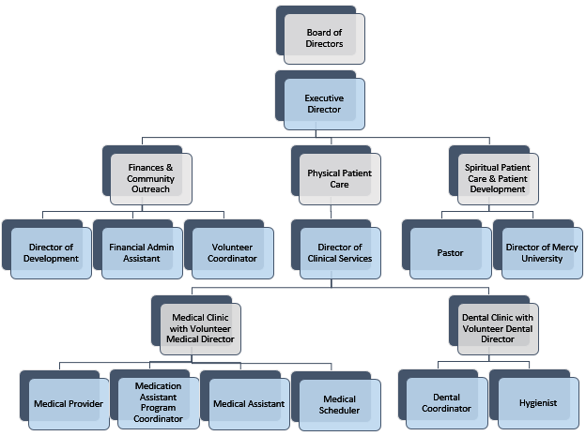
TMM Infrastructure:

Professional Volunteers:
TMM was first developed using the national Volunteers in Medicine (VIM) Model, which promotes a “Culture of Caring” while emphasizing the use of medical and non-medical volunteers. Currently, TMM has 4 + medical providers, 4+ dental providers and 3 licensed professional counselors from Toombs and surrounding counties, that volunteer at least 4 hours a month, helping Mercy to increase its patient capacity and provide services that otherwise could not be provided.
Community Partners:
- Meadows Health – The Meadows Health system does not directly donate funds to The Mercy Ministries, but it provides $500,000 + worth of goods and services to our patients each year through lab and diagnostic testing, surgical procedures, low-cost access to specialty care physicians within the Meadows Health network of providers, and basic medical supplies. In addition, TMM works closely with the Meadows Health Community Wellness Department, providing statistical data on Mercy patients for Meadows to apply for grants related to increasing access to healthcare for low-income patients in rural communities. In return, Mercy’s patients benefit greatly from the grant-funded programs (i.e. mammograms, diabetes care management, and telemedicine for specialty care) that the Community Wellness Department is rewarded.
- City Drugs – City Drugs is Mercy’s local pharmacy partner in providing low-cost, generic prescriptions and over-the-counter drugs to our patients when they cannot get their medicines through Mercy’s Medication Prescription Program.
- Pineland Paper Company – Pineland Paper Company provides TMM with close to $2,000 worth of paper goods, office supplies and cleaning supplies each year, helping us to keep our facilities’ operating costs low.
- Webster Motor Company – Webster Motor Company maintains TMM’s van used for patient transportation.
TMM has many other community partners that provide specific services to our patients at little or no cost based on the service agreement in place, including: Advanced Internal Medicine (Dr. Geoffrey Conner), Southeast Georgia Diagnostic and Prevention Center (Dr. Ronnie Smith), and Georgia Eye Institute (Dr. Lyn Oxley).
Current Funding Sources:
2017 Revenue: $368, 594
About Funding Received from Grants & Foundations…
TMM applies for grants related to its program areas from private foundations, corporate foundations and association/society organizations with charitable arms. TMM DOES NOT directly apply for any grants from the Federal Government, but does apply for some (up to $25k) state funding each year through the Georgia Charitable Care Network, a non-profit entity that is comprised of a network of free and charitable clinics based in Georgia. TMM is also a United Way agency and applies for funding each year from our local United Way organization.

(Note: This does NOT Include in-kind goods/services
provided to our patients by community partners.)

Plan for Sustainability:

In 2016, The Mercy Ministries adopted a strategic sustainable funding plan called the Benevon Model. The Benevon Model is a mission-centered, four-step, circular process for raising sustainable funding and major gifts from individual donors.

Step One: The Point of Entry Event - Potential donors get on the cycle by attending a private Point of Entry Event (which TMM calls “60 Minutes with Mercy”) at the invitation of a friend or colleague who serves as an Ambassador for our organization. This succinct, one-hour introductory event educates and inspires guests with the facts and stories about TMM’s work, focusing on our three overarching areas of impact and capturing each guest's name with permission.

Step Two: Follow Up and Involve or Bless and Release - Guests then receive a personal Follow-Up Call to solicit their feedback and see if they would like to become involved in any way, ideally by becoming an Ambassador and hosting a private “60 Minutes with Mercy” tour. Those guests who are interested in learning more about our organization are involved and cultivated personally in whatever way they prefer. In the Follow-Up Call, Point of Entry guests who are not interested in learning more about your organization are let off the hook completely. This "Bless and Release" will pleasantly disarm people and, paradoxically, allow them to suggest others who would be interested in attending a future”60 Minute with Mercy” tour.

Step Three: Asking for Money - After several personal cultivation contacts to more deeply connect guests to their area of greatest interest, many Point of Entry guests will be ready to be asked for money, either one-on-one or at a Benevon Free One-Hour Ask Event. The Free One-Hour Ask Event is a signature Benevon event. After being cultivated extensively in the months before the event, guests are invited by their Ambassador to attend an inspiring, mission-focused, one-hour free breakfast or lunch fundraising event. At the end of this event, guests are invited to join TMM’s Multiple-Year Giving Society by making a gift of at least $1,000 per year for the next five years. The Free One-Hour Ask Event differs from other, more traditional, fundraising events in that all Table Captains have been Ambassadors in the prior year and their guests will have attended a “60 Minute with Mercy” tour. Also, the Ask Event is free to attend, and there is no obligation for guests to give.

Step Four: Introducing Others - Finally, donors are re-connected to the mission of your organization at program-related Benevon Free Feel-Good Cultivation Events (like Mercy University Graduations), and are encouraged to introduce others to your organization by becoming Ambassadors and hosting their own Point of Entry Events the next year.

